

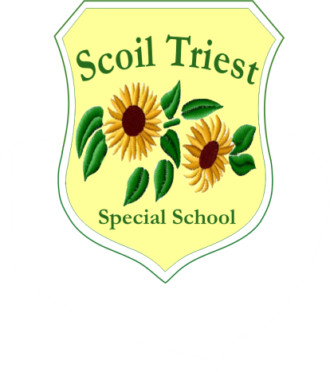

**Scoil Triest Special School**

**Lota, Glanmire, Co Cork**

**021 4556284/4556280/4822916**

**Fax: 021 4821711**

**email: info@scoiltriest.ie**

**Roll No: 19760E**

***Policy:* Wellbeing Policy Scoil Triest**

***Date of Issue:*  October 2021**

|  |  |  |  |
| --- | --- | --- | --- |
| ***Date*** | ***Reviewed / Ratified*** | ***Chairperson’s Signature*** | ***Principal’s Signature*** |
| ***October 2021*** | ***Ratified*** | ***Judith Conway*** | ***Geraldine Bond*** |
| ***November 2023*** | ***Reviewed*** | ***Yvonne Cummins*** | ***Jerry Ryan*** |
|  |  |  |  |
|  |  |  |  |
|  |  |  |  |
|  |  |  |  |
|  |  |  |  |

***WELLBEING POLICY***

***SCOIL TRIEST.***

Here at Scoil Triest we strive to provide a well-ordered, caring, happy and secure atmosphere where the intellectual, spiritual, physical, moral and cultural needs of the pupils are identified and addressed.

***School Triest School Mission Statement:***

Scoil Triest endeavours to create a happy, safe and supportive learning environment where each individual is heard, included and valued. We enable each other to reach our full potential both in school and in the wider community

Central to our ethos and to the holistic development of each child, is the promotion of Wellbeing. The World Health Organisation’s definition of Wellbeing in describing its multi-dimensional nature is:

***“Wellbeing is present when a person realises their potential, is resilient in dealing with the normal stresses of their life, takes care of their physical wellbeing and has a sense of purpose, connection and belonging to a wider community. It is a fluid way of being and needs nurturing throughout life.”***

Scoil Triest takes guidance from the Wellbeing Policy Statement and Framework for Practice (2019) to inform a whole school approach to the promotion of Wellbeing.

We know that the mental health and well-being of our students is critical to success in school and life. Education about well-being is an integral part of the school curriculum. Schools play a vital role in the promotion of positive mental health in children. Schools can also provide a safe and supportive environment for building life skills and resilience and a strong sense of connectedness to school. Listening to the voice of the child and fostering healthy relationships with peers, teachers and school staff are essential to children’s positive experience of school and their cognitive and emotional development. The needs and well-being of school staff are also of paramount importance.

Wellbeing does not necessarily mean the absence of stress or negative emotions in life or the absence of mental health difficulties. It is important that all members of the education community understand that everyone experiences vulnerability and a need for care at some stages in their journey through life. All children and young people may be vulnerable at different stages of their development, and their sense of wellbeing may vary from time to time. Developing, nurturing and sustaining our wellbeing is a lifelong process. Wellbeing is comprised of many interrelated aspects including being active, responsible, connected, resilient, appreciated, respected and aware (DES & NCCA, 2017).

***Role of teachers***

It is essential that all staff continue to develop their competence and confidence in the promotion of wellbeing. The qualified classroom teacher is the best placed professional to work sensitively and consistently with students and she/he can have a powerful impact on influencing students’ attitudes, values, and behaviour in all aspects of well-being education. This can be achieved through accessing continuing professional development (CPD) which includes the sharing of expertise and learning, and having opportunities to model and engage in collaborative working

Please find some examples of how we promote Wellbeing specifically in our own context below:

* The formal instruction of the Physical Education Curriculum is taught across every class level in Scoil Triest.
* Participating in Active Schools
* The formal instruction of the Personal Care &Wellbeing Curriculum is taught across every class level in Scoil Triest
* Access to a comprehensive Sensory Curriculum
* Participating in activities to support various charities
* An annual Fun Run
* Aspects of the Zones of Regulation are used throughout the school
* PALM (Pause, Attune, Label Model and Modify) approach to emotional regulation

*Scoil Triest has a range of resources to promote mindfulness:*

* Yoga and Guided Meditation practised in various classes throughout the school
* Our students have access to a qualified Music and Art teacher during the year?
* Our Student Council promotes student voice for students in the senior part of Scoil Triest.
* Our students have access to beautiful walks on campus

*Some of the aims of fostering Wellbeing in our school are:*

* Our positive nurturing whole school approach to the management of behaviour, including Positive Behaviour Support Plans underpin our culture of well- being in Scoil Triest.
* Developing and maintaining a safe, caring culture and climate within the school where a sense of belonging and connectedness is fostered.
* Building positive relationships between teachers, SNA’s and children to promote participation, social interaction and pro-social behaviour.
* Adopting a whole-school approach to health promotion, where health is promoted by all and not just by a few members of staff.
* Actively involving children, their parents/guardians and the wider community in developing and implementing school policies to support mental health and health promotion.
* Supporting and implementing a well-planned, consistent and integrated curriculum to enable children enhance their coping, resilience, communication, conflict resolution, and problem-solving skills.
* Developing whole-school systems and structures to support the early identification of children experiencing social, emotional, behavioural or learning difficulties.
* Fostering a whole-school ethos that accepts and values diversity within the pupil and staff population.
* Providing easy access to information for pupils’ family and staff on supports available to them within the school and wider community.
* Facilitating access to continuing professional development for school staff on the promotion of the mental health and well-being of children.
* Development of a Well being committee, ongoing wellbeing initiatives for students and staff.
* Promotion of the Employee Assistance Service (EAS) which is provided by Spectrum Life under the logo of ‘Wellbeing Together: Folláine le Chéile’