

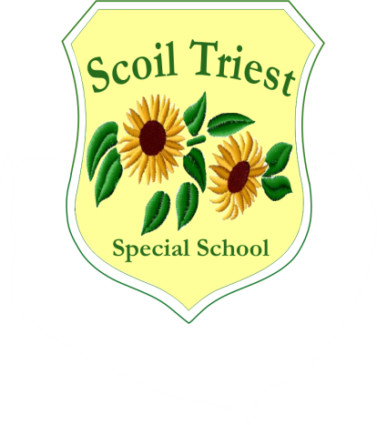

**Scoil Triest Special School**

**Lota, Glanmire, Co Cork**

**021 4556284/4556280/4822916**

**Fax: 021 4821711**

**email: info@scoiltriest.ie**

**Roll No: 19760E**

**Board of Management of Scoil Triest Special School Annual Report**

**Principal’s End of Year Report-November 2023-November 2024**

**Introduction:** This report has been prepared to comply with section 20 of the Education Act,1998. It covers the period from 21st November 2023 to 21st November 2024. It was approved by the Chairperson, Board of Management on November 24th, 2024. The period covers the commencement of a new Board of Management in November 2023

The next report will issue in June 2025.

**Total enrolment:** 72 students were enrolled in the school in the 2024/2025 academic year. 14 students will graduate from Scoil Triest in June 2025. There were 13 school leavers in June 2024, we were delighted to celebrate their graduation day in June 2024. There was a graduation mass in the church followed by a presentation and slideshow on each student in the hall. Refreshments were provided. We were very sad to see our wonderful students leave. We wish them all the very best of luck in Adult Services.

**Spiritual development:** Liturgical services resumed this year following Covid Restrictions. The Confirmation Ceremony took place in April 2024. The Christmas Concert was recorded by each class again this year and all the students in the school took part. The finished video was watched by each class in the school hall. It was a great success and captured very accurately the spirit of Christmas. This play showcased the many talents and abilities of our students. The school also had a Christmas mass in the church in December 2023, the school choir sung beautifully. We also had a beginning of the school year mass in October 2024. This year’s May Altar was a lovely addition to our School. Classes took turns in bringing seasonal flowers to decorate the altar.

**Junior Cycle:** Excellent results were achieved by the students taking the Junior Cycle level 1 and 2. State Certificates were issued to students during an awards ceremony which took place in school with students and their families. We congratulate these students for their significant and proud achievements.

**Department of Education Inspection:** Scoil Triest will receive a Whole School Evaluation by three inspectors of the Department of Education from December 3rd-December 5th (inclusive) 2024. The Inspectorate will meet parents, students, In school Management, teachers and the Board of Management

**Staffing:** The school’s total teacher allocation from the Department of Education for 2024/2025 is 14, this is inclusive of an Administrative Principal and for the first time an Administrative Deputy Principal. The school has also been sanctioned part time teaching hours. The school has 6 part time subject teachers in the areas of, Physical Education, Home Economics, Craft, Art, Music & Horticulture. The school was sanctioned 38 full-time Special Needs Assistant positions for 2024/2025. The school recently had an SNA review above SERC for additional SNA support for the school. The SENO carried out the review in early November 2024, we are awaiting the outcome from the review. Sincere thanks to the hard-working, committed, diligent and talented staff who continue to promote excellence in education in Scoil Triest Special School.

**Children’s Disability Network Teams:** In August 2024, staff of Scoil Triest received training from the East Cork Children’s Disability Network Team. The school received training from the teams Psychologist, Occupational Therapist and Speech & Language Therapist. The Team will be back to the school in early 2025 to meet each class to follow up from the training and offer additional supports. As Principal, I will continue to advocate for more supports from the various Children Disability Network Teams.

**Information Technology (I.T.)** Avril Holland is the Assistant Principal with responsibility for I.T. The school has regular Digital Initiative meetings in order to identify ways to further support and enhance the quality of education for all our students. This year the school invested in upgrading from Aladdin to Aladdin Connect, we always strive to develop effective communication links between school and home. Aladdin Connect continues to monitor the daily attendance of all students. Additionally, text alerts are sent to notify parents of certain school events e.g. dates of parent meetings, in-service training, school closures etc. We are currently looking into allowing families pay for school events and trips online through Aladdin, this would reduce the need for money transactions. The school also updates its school website on a regular basis. Unfortunately, our school website was hacked recently, therefore we must build and develop a new school website. We are pleased to say that this is underway. Several new android devices and reconditioned iPads were purchased to further support the learning experiences for our students. Two new interactive smart whiteboards have been purchased and are utilised daily in the school.

**Extra-curricular and co-curricular activities**: The Board of Management expresses its gratitude to the teaching and SNA staff for organising the following activities for students during the year

* Lámh Choir
* Yoga
* Basketball
* Food Dudes Incredible Edibles
* School Tours
* Educational Outings
* Weekly social outings and trips
* Cork Pops
* Cinema Trips
* Drama
* Zumba

**Child Protection:** The Designated Liaison Person (DLP) is Jerry Ryan, and the Deputy DLP is Niamh Murphy. The Board carried out its annual review of its Child Protection Policy in September 2023 & 2024. The Child Safeguarding Statement and Risk Assessment was reviewed in March 2024 and presented to the Board. The Statement was forwarded to the Patron for approval.

* Mandatory Template 2: Checklist for Review of the Child Safeguarding Statement
* Mandatory Template 3:  Notification regarding the Board of Management's review of the Child Safeguarding Statement.
* All staff of Scoil Triest renewed their Child Protection training
* The Board of Management completed training on child protection

School Development Planning Policies that make up the school plan are available on the school’s website: The following have been the main developments in school planning throughout 2023/2024

* The ongoing review of subject development plans in all core areas.
* Staff continue to develop Junior Cycle level 1 and level 2 programmes.
* Admissions and Enrolment Policy Review in line with developments in Progressing Disability Services (PDS.)
* Code of Behaviour Policy
* G.D. P. R. Policy
* Wellbeing Policy
* All staff had their CPI Training refreshed
* Teachers attended Department of Education and other in-service on-line training in a range of areas, particularly Autism and Wellness training.
* The Code of Behaviour Policy has been reviewed by the Board and adapted in line with the changing needs and demands of the school.
* The Enrolment Policy has been reviewed by the Board 13/11/2024
* The RSE policy was reviewed and distributed to all parents and staff

**Communication with Parents**

A communication letter was sent to all parents in May 2024 and November 2024. Please find them below. The school also sends 4 Newsletters to all families yearly (Halloween, Christmas, Easter & Summer). The school gives an end of year school report to all students within the school. Teachers organise yearly IEP meetings with parents, teachers organise yearly parent teacher meetings, teachers organise yearly IEP review meetings and teachers organise yearly school leaver meetings with parents of students who are school leavers.

|  |
| --- |
| **May 2024**   * From September 2024, Niamh Murphy will become an Administrative Deputy Principal, this is fantastic news for the school as both Niamh & I will have more time to work on planning and developing more ways of developing the school * We have received an increase of specialist teacher hours per week from the Department of Education, this is very welcomed news here in Scoil Triest as it will mean that our students can get more access to Music etc. * We have received an increase of support from the various Children’s Disability Network Teams, however, we will continue to advocate for more support as our students deserve the very best. * Various Adult service providers have been visiting the school over the past few months to profile and support the transition of our current school leavers to adult services in September 2024. We have seen great progress in the offer of adult services for our school leavers, this is very much welcomed. * We have received training and in class support from the Occupational Therapy department in the Brothers of Charity over the past few months. * The staff of Scoil Triest will receive a whole day training from an Occupational Therapist during August 2024. * We have 12 students who will be leaving Scoil Triest in June 2024, we look forward to celebrating their Graduation Day towards the end of June 2024. * We have a new Board of Management within the school. * From September 2024, the National Council for Curriculum & Assessment (NCCA) & the Department of Education are planning to offer a new Senior Cycle Programme for students attending special schools. We are waiting for further information from the Department of Education & NCCA. We will also need training on the new proposed Senior Cycle Programme. * All our teachers received training from Óide recently on ‘Reporting & Assessment’ as part of our Junior Cycle Programme. * IEP reviews are almost completed. * We are planning that all school reports will be sent to families through the Aladdin Connect App this year. * Swimming is a continuing success for our students, it is great that we are now in a position again that we can offer swimming to our students. * We had a coffee morning recently and from the monies raised we have a company coming to our school on June 25th, 2024, to offer all of our students a sensory experience using bubbles, we are all really excited for this day. * Each class are busy preparing for their annual school tours. * Our students will be going to the cinema on a bus on June 24th. * We have 12 new students who will be attending Scoil Triest in September * A social story will be sent to all parents towards the end of June letting you know the class that your child will be attending in September 2024, it will also outline who the Teacher, SNA’s, Peers and Escort will be. * Social Training is continuing to be a great success. * Free Book Scheme for September 2024 is in operation. * Our students had a great time recently celebrating their Confirmation, it was great to meet all families to celebrate our students special day. * Specialist Subject Teachers for Home Economics, Craft, Art, Music, Horticulture & Physical Education are working extremely well for our students. * Developing wellbeing initiatives for both students & staff is always a priority for Scoil Triest * Newsletters are continuing to be sent to all families during the Halloween Midterm break, Christmas, Easter & Summer. * Developing communication links between school & home is always a priority, Aladdin Connect is a great communication tool that is supporting to achieve this. * Flexibility around IEP & Parent Teacher Meetings, many of our parents live a long distance from the school, therefore, we offer our parents the option of attending these meetings face to face, virtually or by telephone. * We had an open evening face to face for parents of new students for September 2024-2025 during March * Fundraising: Christmas & Easter Raffles * Got a new basket swing for the middle yard * We have an Ice-Cream van booked to come to the school on Thursday June 27th, 2024. * We will have a disco in the school on Friday June 28th (Day of the school holidays). Students do not have to wear school uniforms on this day. The school will close at 12:30 this day for the Summer Holidays and Re-open on Monday September 2nd, 2024.   There are many areas that we need to develop within the school, and many are a working progress.  **We want to achieve the following:**   * Access to additional swimming slots * Access to more Multidisciplinary support from the various Children Disability Network Teams. As you know from my previous correspondence, I did write to the Managers on all the various network teams about reinstating full supports to the students of Scoil Triest. I would encourage you all to make direct contact with the Manager assigned to your child’s team. As Principal, I will continue to advocate for this support for all our students. * We want to look at work experience options for our school leavers * We want to introduce more subject choice for our students * More digital initiatives within the school * Try and develop a Parents Association * More fundraising opportunities * Continue developing the links between school and home. |

|  |
| --- |
| November 2024  **Since September we have:**   * Purchased new sensory equipment for our existing sensory room * Created soft padding areas in some of our outdoor spaces off some classrooms * New roof on one of our prefabs. * Social Training: three days per week, many of our students take the bus to local shopping centres, café’s, libraries, restaurants etc * We got new resources for our library, students go there to look at books, draw/colour, complete puzzles, listen to music and relax * Swimming: Each class will receive 10 sessions over a 10-week period this year. * Teachers team teach. * Students have access to teaching from our subject teachers in the areas of Art, Craft, Music, Physical Education, Cookery & Horticulture. * We have a full cohort of In-school Management Team members including Administrative Principal, Administrative Deputy Principal and three Assistant Principals. * Free Book Scheme for September 2024 is in operation. * Free School Lunches is in operation * Drama classes will recommence before Christmas * Students had a Zumba Class Recently * Students went to Cork Pops in the City Hall recently by bus. * We developed a new outside space for red class. * We are fundraising to convert a space we have within the school to a Games Room. * Two staff members recently did a sky dive in aid of the school to raise funds. * We will have a Christmas Crafts Fair in the school on December 13th, refreshments will also be provided * We will be organising a Christmas Raffle to raise funds for the school * We purchased 2 new I-Pads * Three classrooms were recently painted (Pink, Red & Purple) as well as the corridors in the school * Staff receive regular training on LÁMH in school, one of our teachers is a trainer. * Staff training occurs monthly in the school (Training was received on LÁMH, Promoting Positive Behaviour within the classroom, Social Skills, New Autism Guidance, Anxiety, Epilepsy Awareness, Diabetes Awareness etc) * Assembly in school every Monday * Developing wellbeing initiatives for both students & staff * Training for teachers on Curriculum Development & Assessment for the Junior Certificate Level 1 & 2 programmes * Introduction of new Senior Cycle Programme Level 1 & 2 (an email was sent recently to all families outlining this) * Confirmation & Christmas Celebrations * Newsletters- sent to all families at Halloween, Christmas, Easter & Summer * Developing communication links between school & home, the introduction of the Aladdin Connect App is helping to support this * Flexibility around IEP & Parent Teacher Meetings, many of our parents live a long distance from the school, therefore, going forward we are offering our parents the option of attending these meetings face to face, virtually or by telephone. * Development of a LÁMH choir within the school * Return of the mobile library bus * Upgrading of our school website * Opening evening Face to Face for parents of new students for September 2025 * Fundraising-Lots of Initiatives and Events occurring presently * Epilepsy: Administration of Buccal Midazolam Training for all staff * Promoting wellbeing: Wellbeing Initiatives for both students and Staff * Trip to the cinema for students is taking place during December, this will be paid from a donation we received recently. * The Deputy Principal is working closely with several businesses within the area to source work experience for our school leavers * We will be purchasing scooters for our students to drive around our cycle track.   There are many areas that we need to develop within the school, and many are a working progress.  **We want to achieve the following:**   * Access to additional swimming slots * Access to Multidisciplinary support from the various Children Disability Network Teams. * More fundraising opportunities * More specific training for staff * More learning opportunities for our wonderful students. |

The Board of Management Scoil Triest Special School

26th November 2024





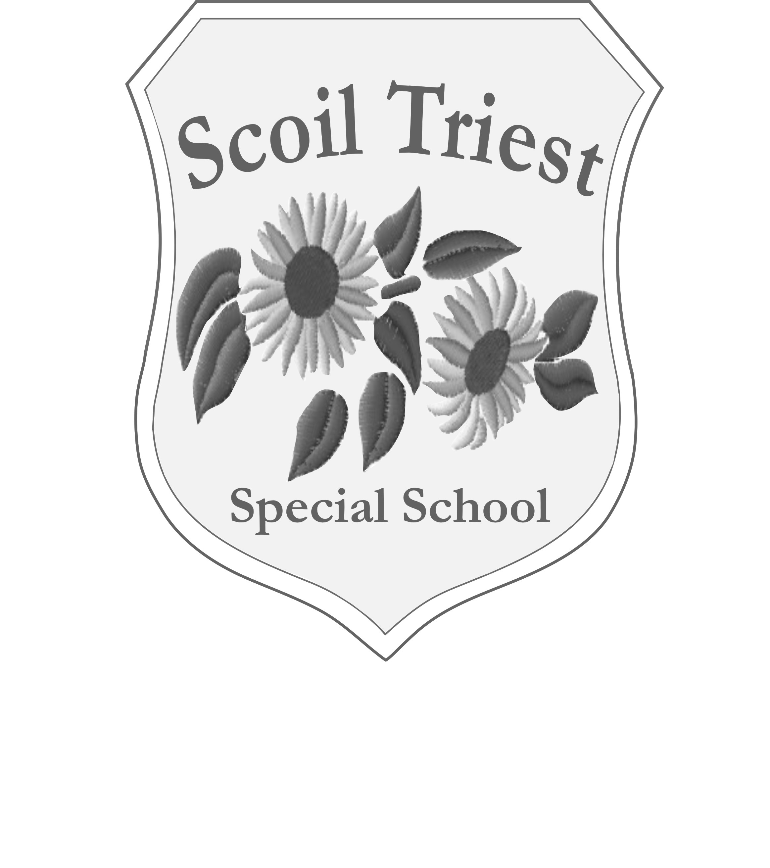

**Scoil Triest Special School**

**Lota, Glanmire, Co Cork**

**021 4556200/456284/4822916**

**Fax: 021 4821711**

**email: info@scoiltriest.ie**

**Roll No: 19760E**