

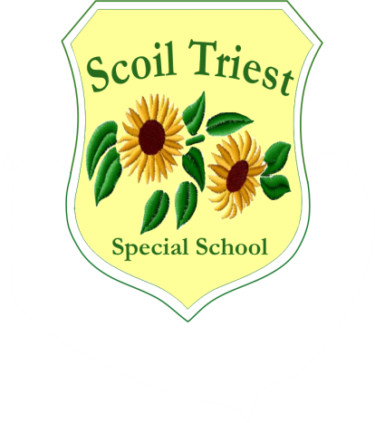

**Scoil Triest Special School**

**Lota, Glanmire, Co Cork**

**021 4556284/4556280/4822916**

**Fax: 021 4821711**

**email: info@scoiltriest.ie**

**Roll No: 19760E**

***Policy:* Confidentiality Policy**

***Date of Issue:*  20th February 2018**

|  |  |  |  |
| --- | --- | --- | --- |
| ***Date*** | ***Reviewed / Ratified*** | ***Chairperson’s Signature*** | ***Principal’s Signature*** |
| ***04/03/2013*** | ***Ratified*** | ***Liam Murphy*** | ***Geraldine Bond*** |
| ***20/02/2018*** | ***Reviewed*** | ***Liam Murphy*** | ***Geraldine Bond*** |
|  |  |  |  |
|  |  |  |  |
|  |  |  |  |
|  |  |  |  |
|  |  |  |  |

***CONFIDENTIALITY POLICY***

***Confidentiality refers to the limited use of information about Scoil Triest pupils, parents and staff which may be obtained by staff during the course of their work.***

N.B. “Staff” refers to **ALL** staff in Scoil Triest including Multi-disciplinary team members, students on placement, substitute staff and Bus escorts.

1. Sharing of any information should be done only on a need to know basis and only when it is in the best interest of the pupil or staff member concerned.
2. When meeting with parents, only information relating to their own child should be discussed. Staff should decline to enter into any conversation relating to other pupils in the school.
3. Pupil / school business should not be discussed outside school hours during social occasions by any member of staff. School business should not be discussed on transport vehicles or in areas of the school environment or in the Lota Canteen where non staff members may be in a position to hear. It is particularly important not to identify any student by full name outside of the school building / premises.
4. Discussion of pupil / school business is strictly forbidden on social networking sites. Engagement in discussion about any social networking sites with Scoil Triest pupils should be discouraged and distraction strategies should be used.
5. Care must be taken when commenting on a pupil’s actions or behaviours, personal or family circumstances during conversations in the staff room. Only positive affirming comments may be made in the presence of others.
6. Students on placement can be made aware of Individual Behaviour Management Plans where relevant and at the discretion of the teacher.
7. Care must be taken when interacting with pupils and staff from other schools as part of our integration programme. Staff should not engage in

any discussion about our pupils or their families with staff from other schools. Only positive affirming comments should be made. If staff or pupils from these schools persist in asking questions however well meaning, please inform the Principal of Scoil Triest.

1. Meetings involving confidential details in relation to school or pupil / family business should not take place in a public area where discussion can be overheard.
2. Family preference for privacy should be respected at all times. Individual families should always be consulted before any photos, videos, etc. are permitted to be used in the media or in any public arena e.g. newspapers, t.v., websites, for use in 3rd level student projects etc. A distinction should be made if material is to be used for professional training. Specific permission forms are circulated to parents in this instance.
3. Displaying of photos of pupils and their work is commonly practised throughout the school. Photograph displays with pupils’ first names should always portray pupils in the best positive light.
4. Parents should only receive photos of their own child. In some instances (i.e. School leavers collage) photos of other pupils are included. In this event permission to circulate their photos should be received from the parents of the other pupils.
5. Names, address and phone numbers of any family should not be circulated to anyone without their consent. Names, address and phone numbers should not be on public display in the school or in individual classrooms.
6. Any information, written or recorded relating to a pupil is regarded as private and confidential and is only available to specific / relevant members of the school team and family. Such information can be released with recorded consent of parents.
7. Private and sensitive information relating to a pupil and his / her family which comes to staff attention should only be discussed with the School Principal, Deputy Principal or the most senior teacher present in the school and should not be shared publicly.
8. Behaviour records and attainment records for individual pupils should not be publically displayed in classrooms and should be identified by pupils initials rather than full names.

I, ________________________ have read the above Confidentiality Policy in relation to Scoil Triest Special School and agree to abide by it.

______________________ Date: ___________________

______________________

PRINCIPAL

Any breach of this policy may result in disciplinary action being taken by the Board of Management.

Please ensure that any breach of this Confidentiality Policy is reported to the School Principal / Deputy Principal or most senior member of staff.

***RATIFIED BY B.O.M. March 2013***